GameZone Sales Analysis: Data Cleaning Project

1. Project Background & Business Overview
GameZone is a global e-commerce company (started in 2018) that sells new and refurbished gaming hardware through its website and mobile app. They have a solid amount of data on sales, marketing, and shipping, but it hasn’t been fully used for business decisions yet.
I took on this project to clean and structure over 20,000 raw transaction records. The main goal here is to hand over a clean, reliable dataset to the business team so they can look at overall sales trends across different global regions without getting incorrect results because of messy data.

What the Business Cares About:
Try to understand overall sales trends across a variety of different regions.

2. Understanding the Data Structure
Before writing any cleaning formulas, I spent time understanding the "story" behind each row in the dataset:
- The Grain: Every single row represents a unique customer order identified by an Order ID.
- The Metric: The primary number we care about is USD Price (this is our revenue).
- The Dimensions: We have time details (Purchase_Timestamp, Ship_Timestamp), product names, platforms used, marketing channels, and country codes.

Story of one example record:

“User XYZ placed an order on Dec 24th 2020 that got shipped out two days later.
It was a Nintendo Switch that was bought for almost $170 and it was purchased on the website.
And the user came to Gamezone through affiliate Marketing and we don’t actually know how their account was created but they are located in the United States.”
I followed two strict rules to keep a proper paper trail:
- Never Touch the Raw Data.
- Use Column Versioning.

3. Executive Data Quality Summary
First Pass at Data Cleaning:
- Eyeball for obvious issues.
- Filter to check distinct values.
- Document in the Issue Log.
After running a quick sanity check across the columns, the overall data quality is actually quite good. Key fields like revenue and geography are mostly complete. However, I found a major logic issue in the shipping dates that affects about 10% of the entire dataset.
As an analyst, my instinct wasn't to just delete these rows. Deleting 2,000 orders just to make the data look "perfect" would wipe out a huge chunk of valid sales data and ruin our revenue reports. Instead, I fixed the minor typos programmatically and documented the bigger logic errors so the other team could look into the root cause.

4. Data Quality Audit & Issues Log
Here is the exact log of the issues I found, how big they were, and the logic behind my decisions:
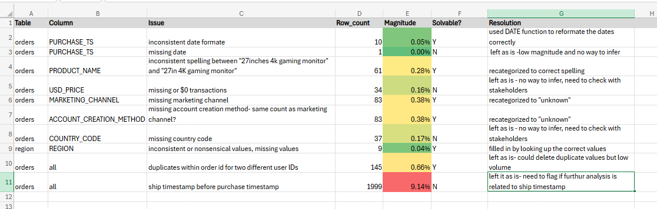

5. Data Augmentation(Adding Value)
Once the data was clean, I started thinking “How can I make my data more flexible & robust?”
In this case,
- I could slice my Purchase_timestamp into weeks, into months and years. Or could do the same for Shipment_timestamp but since time is not our key dimension, so not going to focus on that.
- I could calculate Time_To_Ship, calculating timestamp can be helpful in days knowing that we have some records where shipment date is before purchase date, it will come up as negative.
- I could bring in the Region to my lookup table, so I can see for every single purchase what region it was actually purchased in?
- If I had a user and customer table to reference then maybe I could pull in more demographics info like their street address, state or other info collected when they Sign up for an account.

6. Future Scope (How I'd scale this)
Data in the real world is never 100% perfect. If I were managing this data pipeline on the job, here is how I would approach scaling this process:
- Fix the Source: The 10% shipping date error is clearly a system bug. I would sync with the software developers to add front-end validation on the website so a shipping date can never be entered as earlier than a purchase date.
- Automate Data Checks: Instead of checking for duplicates or nulls manually in Excel or via ad-hoc scripts, I would set up automated data quality tests (using tools like dbt or Python scripts) to automatically flag these rows the moment new data enters the system.

My Full Data Cleaning Process straight from my head:

I understood the dataset by identifying the grain, metrics & dimensions and making sure that I can tell the story of an example record in the data.
I located solvable issues by conducting a first pass of cleaning and dealing with what I can in that process and then evaluated the unsolvable issues where I documented what I was finding and referred to another team if possible otherwise just leave it as is.
Then I started augmenting the data by what other info is available to me that I could use to make the dataset even more interesting.
And then finally, I noted and documented everything in the issue log.

One thing I have learned here is that data cleaning is like peeling onions, this is just the basics I have done here. More EDA and Data Cleaning is coming up in future.

